IMPLEMENTING CRM FOR RESULT TRACKING OF A CANDIDATE WITH INTERNAL MARKS (DEV)-(SHORT –TERM)

**Team ID :** LTVIP2023TMID11579

**Team Leader :** N KARTHIK

**Team member :** K BALACHANDRA

**Create A Screen Flow**

1. Click on Gear icon and select setup

2. In Quick find Box enter flow and select the flows

3.Click on New flow and Select Screen flow

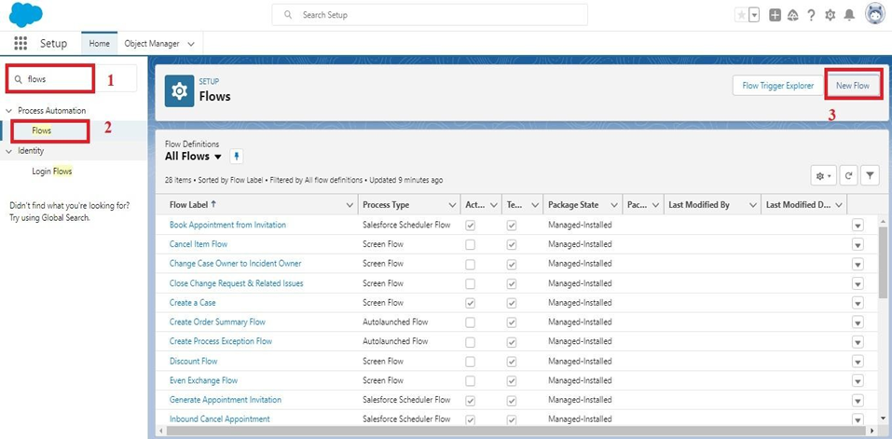

4.It will open the canvas. Select (+)

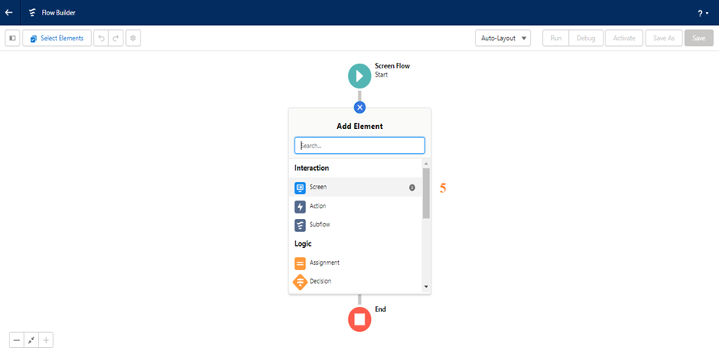

5.Select the screen element from the drop down.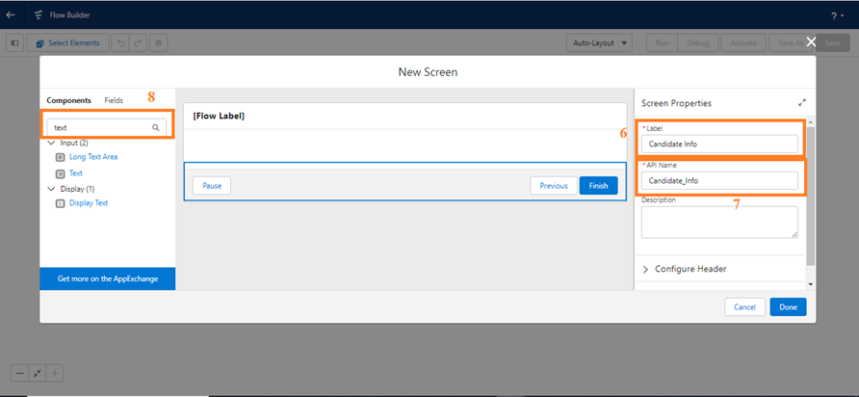

6.It will open the dialog box. Now give the label name and api name will be auto populated. These labels are for your screen Element.

     Label: Candidate info

     API Name: Candidate_Info (This field will be auto populated.)

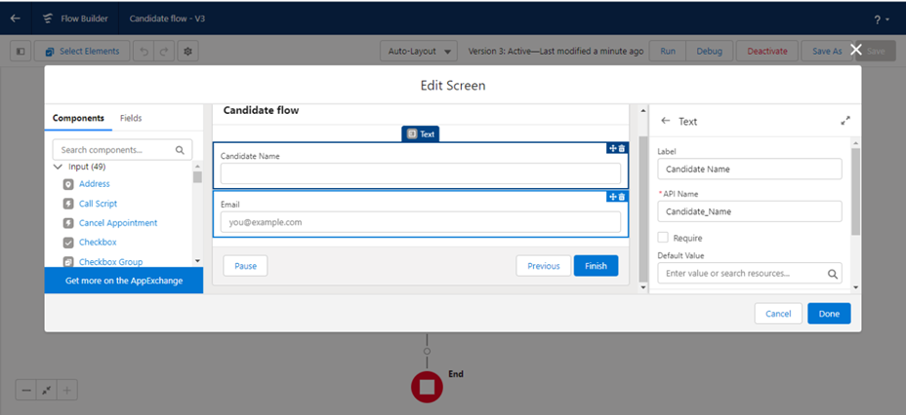     7..In search Component type text and drag the text component to canva and give the label and Api Name

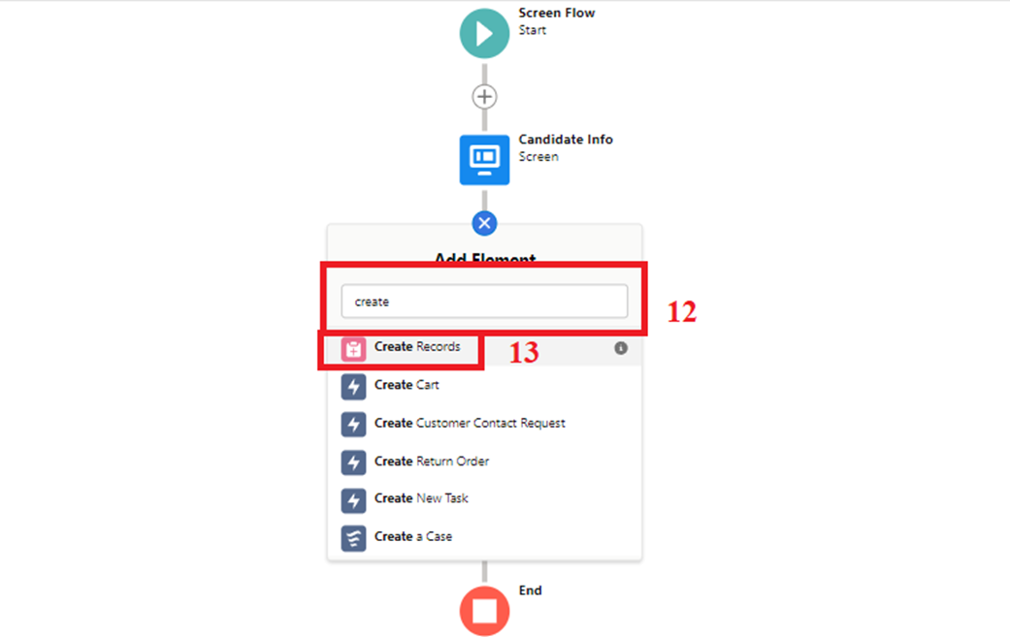

8.   8.Similarly, Add Email Component also.

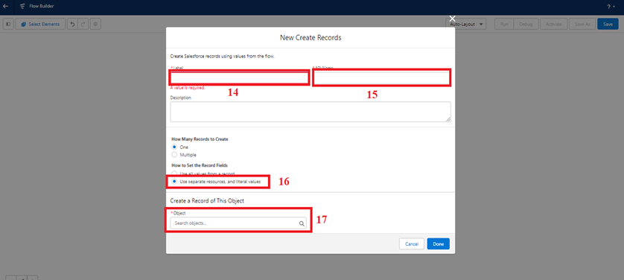    19.Enable Subject and Give Welcome

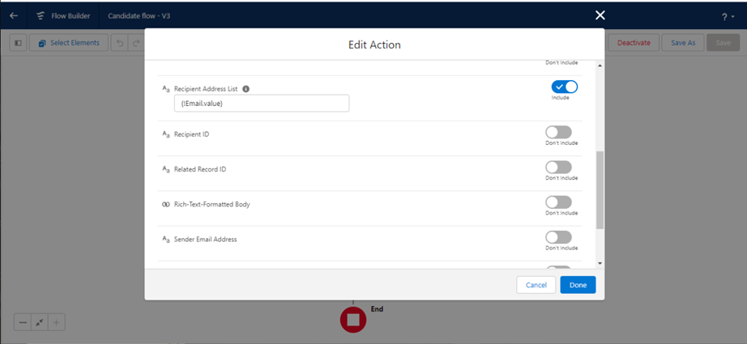Flow label: Candidate flow

      Flow API Name: Candidate_flow (this will be auto populated)

     20.Click on save

     21.Click on the Activate.

### xxxxxx.png

**Create An App Page**

1. Click on the Gear icon and select set up.

2. In Quick Find Box . Type app Builder and select the lighting app builder

3. Select New

### zzzzz.png

### 4.Select the App page and click on Next

### cccc.png

5. Give the label Name.

Label Name: Candidate App page.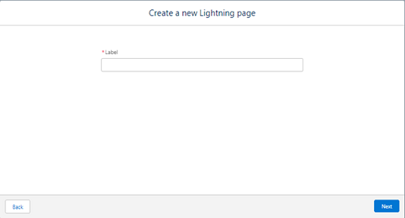   
6. Select the one region and click on finish.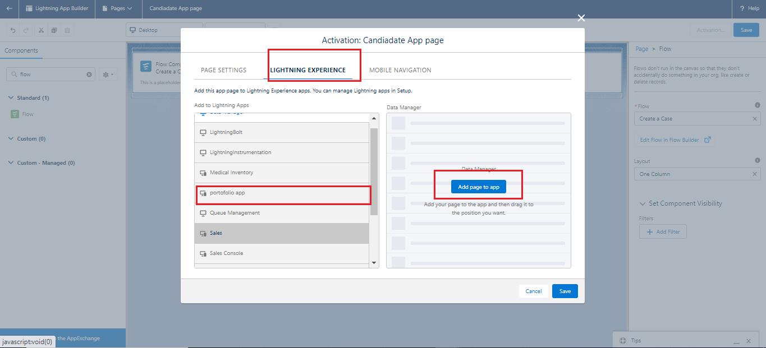   
7. Type the flow in the search bar and select the flow component and drag the component to the Add components here.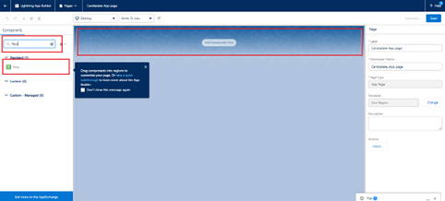

8. After dragging the component, give the flow label in the flow search and then click on save and then click on activate. Flow label:Candidate flow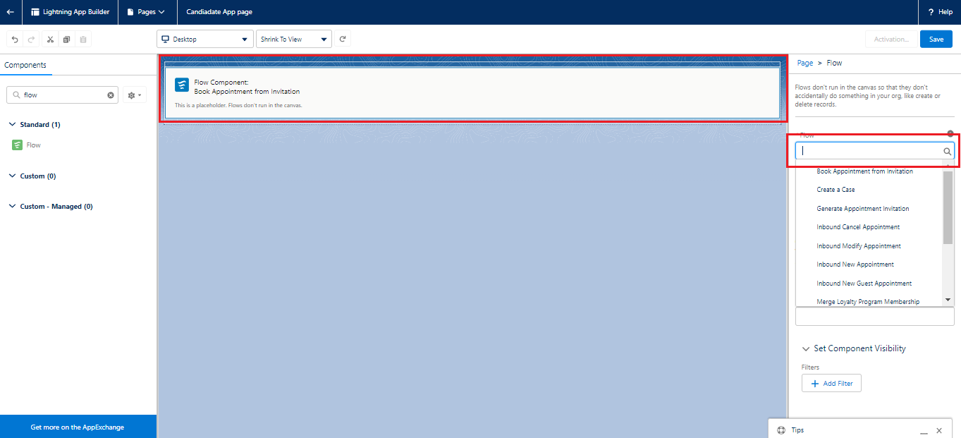  
9. After clicking on the activate it will open a page and then select the lightning experience and select the app and then click on add page to the app.



**Field Update Using Trigger**

Whenever a internal Marks is inserted if the marks is greater than or equal to 200 it must update the status field to Pass or else it must update to fail

1. Go to the gear icon and select the developer console.

2. From the menu bar click on file and select Apex class.

3. Now give the class name as InternalmarksHandler

4. Now Write the  below code

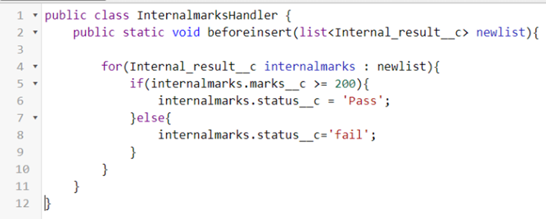

public class InternalmarksHandler {

    public static void beforeinsert(list<Internal_result__c> newlist){

        for(Internal_result__c internalmarks : newlist){

            if(internalmarks.marks__c >= 200){

                internalmarks.status__c = 'Pass';

            }else{

                internalmarks.status__c='fail';

            }

        }

    }

}

5. From the menu bar click on file and select Apex trigger.

6. Now give the trigger name as Internalmarks

7. Now write the below code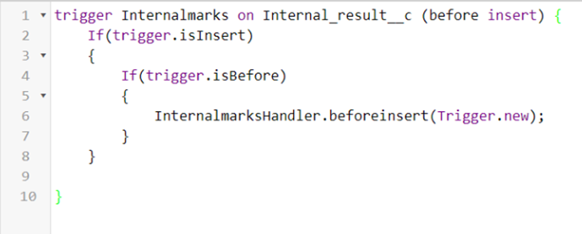

trigger Internalmarks on Internal_result__c(before insert,after update) {

    If(trigger.isInsert)

    {

        If(trigger.isBefore)

        {

            InternalmarksHandler.beforeinsert(Trigger.new);

        }

    }

}

8.Trigger Working as follows:  
   In the following record Marks field is given as 300,Now trigger triggers and  
   status changes to Pass